**APPLICANT DECLARATIONS**

**1. Declaration**

1.   Has the registering organization that intends to submit proposal under Terms of Reference of the RPL or its owners/Directors ever been convicted by a court for any criminal offence or any other offence involving moral turpitude or fraud or have been found guilty of any economic offence at any time in the past?.

 

2.  Has the registering organization that intends to submit proposal under Terms of Reference of the RPL been associated with an organization or its owners/directors been an employee or director of an organization or over which applicant organization or its owners/directors exercised management or policy control, or ever been convicted of any criminal offence or any criminal suit filed during the period of association?.

 

3.   Has the registering organization that intends to submit proposal under Terms of Reference of the RPL or its owners/directors ever been found guilty by any court / regulatory body / self-regulatory organization / stock exchange for any offence in India or abroad?.

 

4.   Has action ever been taken/initiated against the registering organization that intends to submit proposal under Terms of Reference of the RPL or its owners/directors by the Ministry of Skills Development and Entrepreneurship (MSDE) or Any Ministry or NSDC for suspension or cancellation or debarring or blacklisting, or any show cause notice issued for acts committed during undertaking of implementation of any projects in the past ?.

 

5.  Has the registering organization that intends to submit proposal under Terms of Reference of the RPL or its owners/Directors ever been associated with any organization as a director or an employee of such organization against which the Ministry of Skills Development and Entrepreneurship (MSDE) or Any Ministry or NSDC had initiated action/taken action of suspension or cancellation or debarring or blacklisting, or any show cause notice issued for acts committed during the period of association?.

 

**2. UNDERTAKING**

 All information uploaded in the proposal and documents submitted by us (Name of Applicant Organization) are true and correct.*

 I am aware that application fee charged is not refundable and I am also aware that the payment of fee does not guarantee any target allocation to my organization.*

 We shall provide any additional information or documentary evidence deemed necessary for the proposal submitted by us and its evaluation during various stages..*

 I certify that the information provided by me with respect to the organization, authorized signatory and head of the organization will form part of the organization evaluation process and due-diligence in the event of my application for allocation of the target under the terms of reference of the RPL and will not be changed after submission of the registration form.*

 That we agree that NSDC shall, at all times, have the complete rights to share the credit information relating to us and / or our officials/directors/employees etc. as deemed appropriate, with CIBIL or any other institution as approved by RBI from time to time.*

 I have taken a print out of the completely filled-in application form and have read all of its details carefully and certify that the information furnished in this application and all the corresponding documentary proof provided a) has been checked and approved by owners/ managing directors/ trustees and b) is complete and correct in all respects.*

 I undertake that I have not set-up a training center solely for the purpose of the RPL and shall not claim any target allocation.*

 I, as an authorized signatory, have downloaded the declaration cum undertaking and have signed the document myself and affixed the seal of the organization.*

 That we are in compliance with all applicable laws including but not limited to labour laws, environmental laws, tax laws, industrial laws.*

 That we have not been blacklisted by any Central/State Government Agency/Body/Corporation.*

 That we have not directly or indirectly or through an agent engaged or indulged in any corrupt practice, fraudulent practice, coercive practice, undesirable practice or restrictive practice in respect of any proposal submitted by us or any agreement entered into by us with NSDC or any other public sector enterprise or any government, Central or State.*

 That we have taken steps to ensure that no person acting for us or on our behalf has engaged or shall engage in any corrupt practice, fraudulent practice, coercive practice, undesirable practice or restrictive practice.*

 That we, in regard to matters other than security and integrity of the country, have not been convicted by any Court of Law or indicted or adverse orders passed by a regulatory authority which could cast a doubt on our ability to provide the Services under RPL / Contract or which relates to a grave offence that outrages the moral sense of the community.*

 In case any discrepancy is identified/brought to the notice of NSDC after allocation of project; NSDC reserves the right to initiate actions such as including but not limited to revoking of targets, non-payment of training cost incurred, financial recovery of training cost and/or all money already released, blacklisting of Applicant Organization, etc.*

Upload Signed Declaration copy :

Name of Authorised Legal Person :

Rahul

Place of Submission :

Noida

Date of Submission :

03/03/2020

**DECLARATIONS AT PROPOSAL SUBMISSION PAGE**

~~I am aware that my application does not entitle for sanction of project to my organization.*~~



The applicant agrees that they have read and understood the PMKVY ~~and SMART~~ Guidelines before submission of proposal and they shall not seek for any relaxation of norms in implementation of the scheme and will abide by all the frameworks and guidelines issued as and when approved.*



~~NSDC shall NOT accept any proposal after the last date of proposal submission as provided under the corrigendum for the Request for Proposal (RPL) for providing Skill Training under PMKVY 2016-20. Once submitted, NO requests of any modification/alteration/change to the proposals will be accepted by NSDC. NSDC does NOT assume any responsibility or liability for any errors or omissions in the proposal(s) submitted.*~~

**Declaration for Blacklisting/ Suspension \***

Certificate on PIA letterhead by authorized signatory that the organization is not blacklisted/ suspended/ issued any show-cause notice/ warning by any Central/ State government. (If yes, please provide details in the letter)*

**Declaration for Financial Debt/ Insolvency** *

Provide a certificate on letter head of PIA by authorized signatory that PIA is not under any financial debt/ has not applied for insolvency at the time of submission of proposal.

**Declaration for Correct Information** *

Please provide a certificate on letterhead of PIA by authorized signatory that all information provided by the PIA is correct, verified, and no available material information has been suppressed.

Name of Authorized Legal Person

Place of Submission *



Date of Submission

03/03/2020

**TOTAL PROJECT COST CALCULATIONS FOR TYPE 1,2,3**

Following cost components are covered -

|  | **A** | **B** | **C** | **D** | **E** |
| --- | --- | --- | --- | --- | --- |
| **SN** | **Pay-out Heads** | **Max. amount per candidate (in Rs.)** | **Total amount proposed per candidate by PIA (in Rs.)** | **Total project amount proposed by PIA (in Rs.)** | **% of total amount proposed** |
| **1.** | **Payout to PIA** | 1700/1400/1600  (Type 1/2/3) | *Sum of a+b+c+d | No. of Candidates Proposed *A | (SN1/SN6)*100 |
| a. | Mobilization | 500 |  |  | (a/1)*100 |
| b. | Orientation | - |  |  | (b/1)*100 |
| c. | Job Role Kit | 500 |  |  | (c/1)*100 |
| d. | Branding & Publicity | 250 |  |  | (d/1)*100 |
| **2.** | **Payout to SSC (Assessment)** | As per Common norms matrix | If more than one job role is involved, create separate rows for each job role and calculate total payout to SSC by adding individual payout against each job role |  | (SN2/SN6)*100 |
| **3.** | **Payout to Candidate** | **500 (fixed)** | **500** |  | (SN3/SN6)*100 |
| **4.** | **Payout for Bridge Course** | As per common norms matrix | If more than one job role is involved, create separate rows for each job role and calculate total payout to SSC by adding individual payout against each job role |  | (SN4/SN6)*100 |
| **5.** | **NIA Payout** | **76.70 (fixed)** | **76.70** | No. of Candidates Proposed *A | (SN5/SN6)*100 |
| **6.** | **Total (1+2+3+4+5)** | **Total (1+2+3+4+5)** | **Total (1+2+3+4+5)** | **Total (1+2+3+4+5)** | **-** |

**Payout to SSC (Assessment) –**

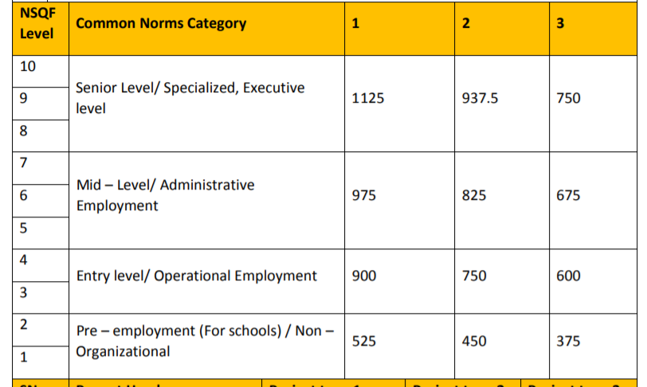

Note the following –

1. *NIA payout at SN5 is inclusive of PIA payout at SN 1. However, it is displayed separately. Put a filter at SN 1 and SN5, maximum value at both combined should not exceed INR1700/1400/1600 per candidate and SN5 should always be INR76.70. Whatever value is filled in by PIA at SN1, INR76.70 is automatically deducted from it and then remaining value should be displayed at SN1.
2. See two examples of project cost calculations for different projects.

**Example 1.**

**Proposed Sector and Job Role(s) -**

| **SN** | **Sector** | **Job Role (with QP code)** | **Target requested** |
| --- | --- | --- | --- |
| 1 | Textiles and Handlooms | Kalamkari Artisan (TSC/Q7402, NSQF Level 4) | 2,000 |
| 2 | Two Shaft Handloom Weaver (TSC/Q7303, NSQF level 4) | 17,200 |
| 3 | Warper (TSC/Q7302, NSQF level 3) | 500 |
| 4 | Hank Dryer (TSC/Q7201 , NSQF Level 4) | 500 |
| **Grand Total** | | | **20,200** |

| **S. N** | **Cost head** | **Per candidate cost (SC Recommended)** | **Total project cost (SC Recommended)** |
| --- | --- | --- | --- |
| 1 | **Pay-out to PIA** | 1623.30 | 3,27,90,660.00 |
| 2 | **Pay-out to SSC** | 900.00 | 1,81,80,000.00 |
| 3 | **Pay-out to Candidate** | 500.00 | 1,01,00,000.00 |
| 4 | **Kaushal Bima Payout** | 76.70 | 15,49,340.00 |
| 5 | **Payout for Bridge Course** | 0.00 | 0.00 |
| 6 | **Total Per Candidate Pay out** | **3100.00** | **6,26,20,000.00** |

**Example 2.**

**Proposed Sector and Job Role(s) -**

| **SN** | **Sector** | **Job Role (with QP code)** | **Target requested** |
| --- | --- | --- | --- |
| 1 | Green Jobs | Safai Karamchari NSQF Level 3  (SGJ/ Q1602) | 10,000 |
| 2 | Plumbing | Plumber General NSQF Level 3  (PSC/ Q0104) | 10,000 |
| **Grand Total** | | | **20,000** |

| **S. N** | **Cost head** | **Per candidate cost (SC Recommended)** | | | **Total project cost (SC Recommended)** |
| --- | --- | --- | --- | --- | --- |
| 1 | **Pay-out to PIA** | 0.00 | | | 0.00 |
| 2 | **Pay-out to SSC** | Safai Karamchari | | 600.00 | 60,00,000.00 |
| Plumber General | | 900.00 | 90,00,000.00 |
| 3 | **Pay-out to Candidate** | 500.00 | | | 1,00,00,000.00 |
| 4 | **Kaushal Bima Payout** | 76.70 | | | 15,34,000.00 |
| 5 | **Payout for Bridge Course** | 0.00 | | | 0.00 |
| 6 | **Total Per Candidate Pay out** | Safai Karamchari | **1,176.70** | | **2,65,34,000.00** |
| Plumber General | **1,476.70** | |